Online Booking Instruction
Please follow the below 8 steps to make reservation under hotel website.
- Go to www.royalplaza.com.hk
- Select Arrival and Departure Dates
- Type in Promo Code “ICAM”
- Click on Check Availability
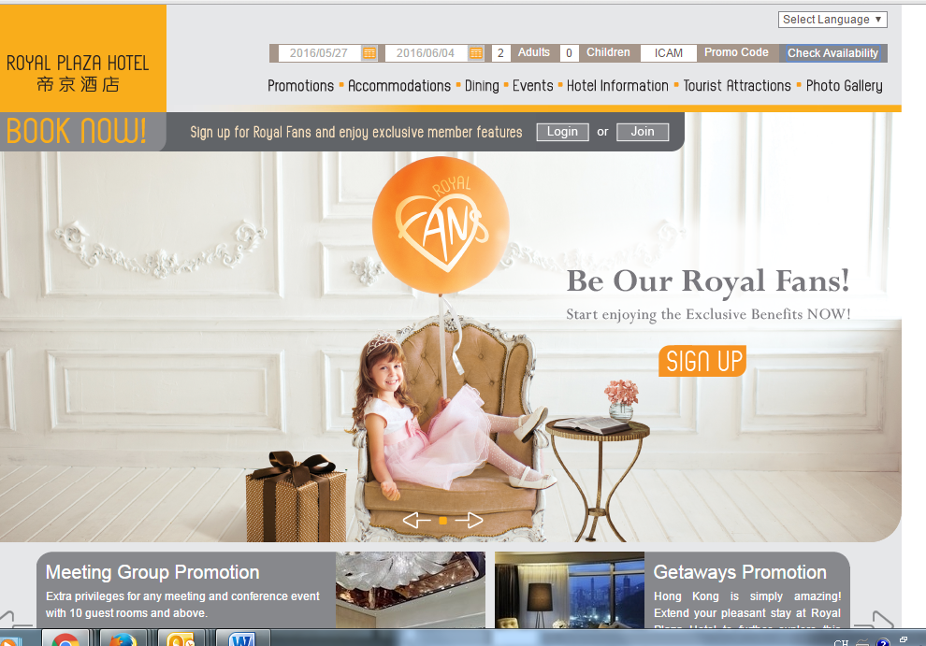
- Select Room Type and Currency
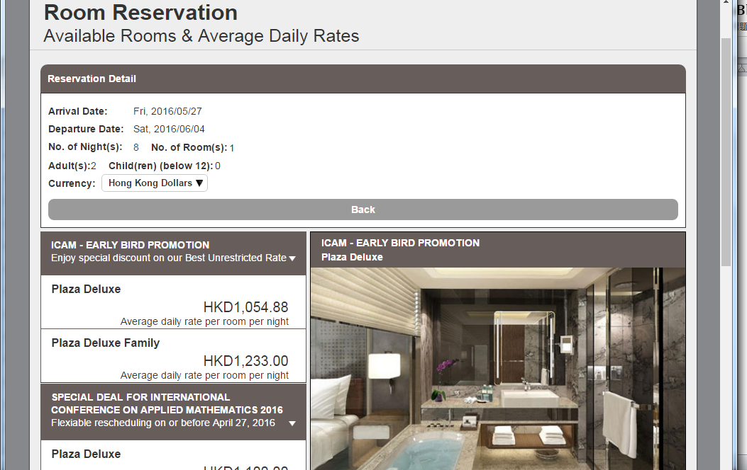

- Please read through Terms & Conditions before click on “Select This”
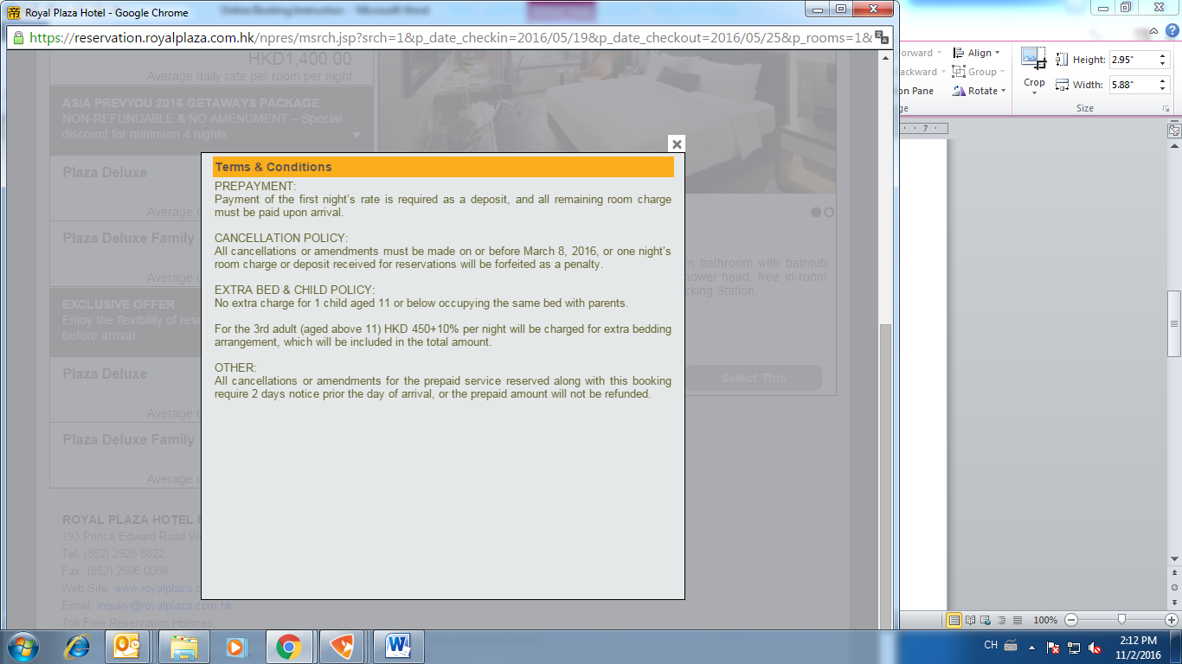
- Select Package (Airport pick-up arrangement) and click on “Continue”
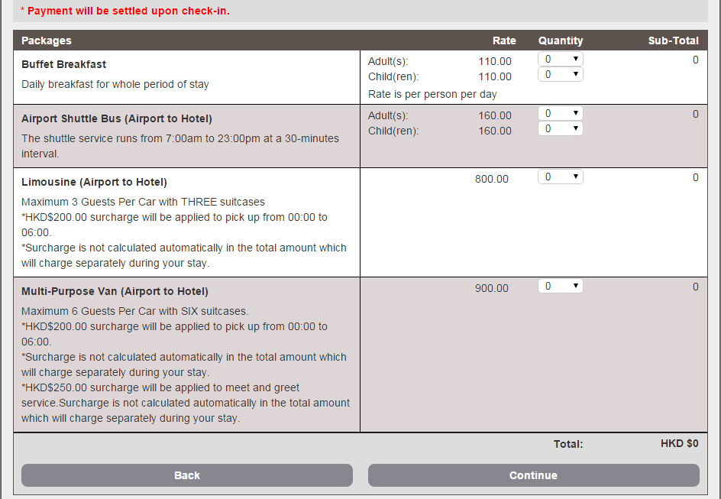

- Type in Guest Information and click on “Continue”
